IMPLEMENTATION MODEL: MAPPING DESIGNS TO CODE
Introduction
Interaction diagrams and DCDs provide sufficient detail to generate code for the domain layer of objects.
The UML artifacts created during the design work, the interaction diagrams and DCDs, will be used as input to the code generation process.
The UP defines the Implementation Model that contains the implementation artifacts such as the source code, database definitions, JSP/XML/HTML pages etc.
Programming and the Development Process
There is prototyping or designing while programming as well!!
Modern development tools provide an excellent environment to quickly explore alternate approaches, and some (or even lots) design-while-programming is usually worthwhile.
Visual modeling before programming is helpful
The creation of code in an object-oriented programming language—such as Java or C#—is not part of OOA/D; it is an end goal.
The artifacts created in the UP Design Model provide some of the information necessary to generate the code.
A strength of OOA/D and OO programming—when used with the UP—is that they provide an end-to-end roadmap from requirements through to code.
Creativity and Change during Implementation
Some decision-making and creative work, are accomplished during design work.
However, the programming work is not a trivial code generation step—quite the opposite.
Realistically, the results generated during design are an incomplete first step; during programming and testing, numerous changes will be made and detailed problems will be uncovered and resolved.
The design artifacts provide a resilient core that scales up with elegance and robustness to meet the new problems encountered during programming.
Hence, expect and plan for change and deviation from the design during programming.
Code Changes and the Iterative Process
A strength of an iterative and incremental development process is that the results of a prior iteration can feed into the beginning of the next iteration.
Thus, subsequent analysis and design results are continually being refined and enhanced from prior implementation work.
For example, when the code in iteration N deviates from the design of iteration N (which it inevitably will), the final design based on the implementation can be input to the analysis and design models of iteration N+l.
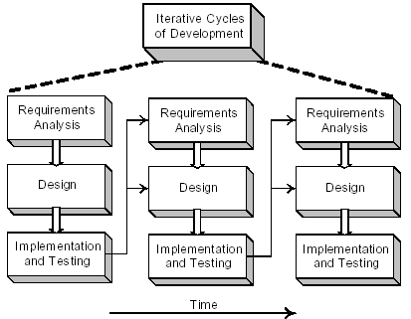
An early activity within an iteration is to synchronize the design diagrams; the earlier diagrams of iteration N will not match the final code of iteration N, and they need to be synchronized before being extended with new design results.
Code Changes, CASE Tools, and Reverse-Engineering
It is desirable for the diagrams generated during design to be semi-automatically updated to reflect changes in the subsequent coding work.
Ideally this should be done with a CASE tool (like Rational Rose) that can read source code and automatically generate, for example, package, class, and sequence diagrams.
This is an aspect of reverse-engineering—the activity of generating diagrams from source (or sometimes, executable) code.
Mapping Designs to Code
Implementation in an object-oriented programming language requires writing source code for:
• class and interface definitions
• method definitions
Creating Class Definitions from DCDs
DCDs depict the class or interface name, superclasses, method signatures, and simple attributes of a class.
This is sufficient to create a basic class definition in an object-oriented programming language.
Defining a Class with Methods and Simple Attributes
From the DCD, a mapping to the basic attribute definitions and method signatures for the Java definition of SalesLineItem is straightforward
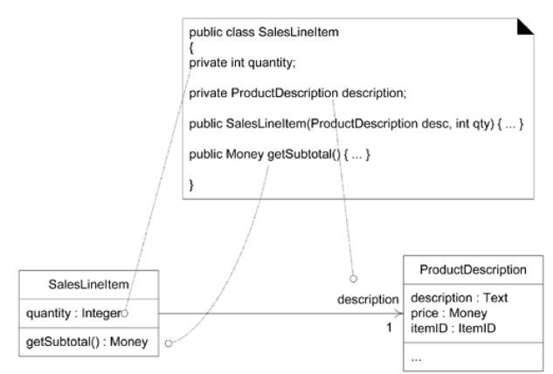
The Java Constructor public SalesLineItem(ProductDescription desc,int qty) is created from the create(desc,qty) message sent to SalesLineItem in the enterItem interaction diagram

Adding Reference Attribute
A reference attribute is an attribute that refers to another complex object, not to a primitive type such as a String, Number, and so on. (i.e. and object as a attribute of another object)
For example, a SalesLineItem has an association to a ProductDescription, with navigability to it. This is a reference attribute in class SalesLineItem that refers to a ProductDescription instance although we have added an instance field to the definition of SalesLineltem to point to a ProductDescription, it is not explicitly declared as an attribute in the attribute section of the class box.
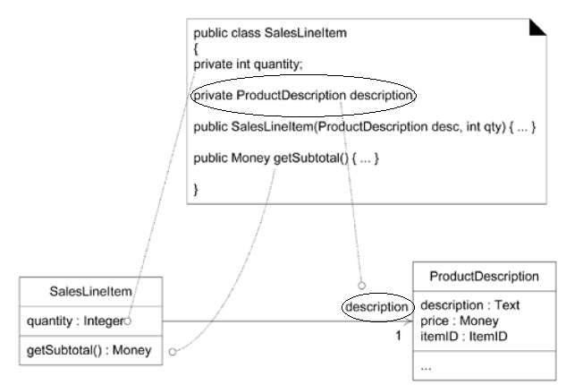
There is a suggested attribute visibility indicated by the association and navigability (description) —which is explicitly defined as an attribute during the code generation phase. In this case, an object A sees another object B, so that object A can pass message or invoke methods of that object B

Reference Attributes and Role Names
A role name is a name that identifies the role and often provides some semantic context as to the nature of the role.
If a role name is present in a class diagram, use it as the basis for the name of the reference attribute during code generation.
In other words, the role name in the class diagram description becomes the name of the reference attribute description of the class SalesLineItem
Role name used in attribute name
Mapping Attributes
In some cases one must consider the mapping of attributes from the design to the code in different languages.
That is , in some languages attributes can be merged into one while mapping from design to code.
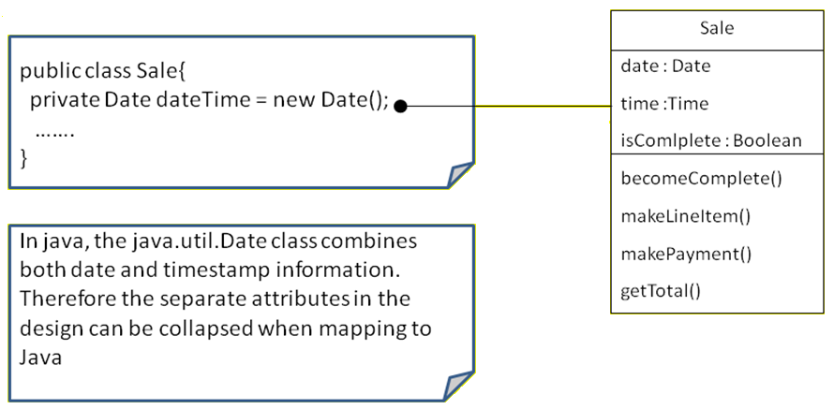
For example, a Date class in Java combines both data and time information hence while implementing the class a single variable dateTime can be used instead of separate attributes date and time

Creating Methods from Interaction Diagrams
An interaction diagram shows the messages that are sent in response to a method invocation.
The sequence of these messages translates to a series of statements in the method definition.
Consider the enterItem communication diagram
The enterItem interaction diagram illustrates the Java definition of the enterItem method. 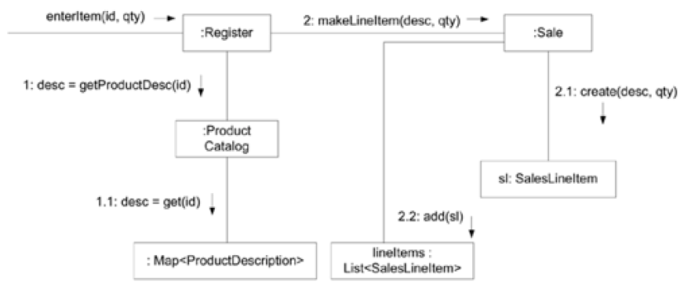
The enterItem message is sent to a Register instance so the enterItem method is defined in the Register class
public void enterItem(ItemID itemID, int qty)
Message 1: A getProductDescription message is sent to the ProductCatalog to retrieve ProductDescription
ProductDescription desc = catalog.getProductDescription(itemID);
Message 2: A makeLineItem message is sent to the Sale
currentSale.makeLineItem (desc,qty);

So it takes the form:
public void enterItem(ItemID itemID, int qty){
ProductDescription desc = catalog.getProductDescription(itemID);
currentSale.makeLineItem (desc,qty);
}

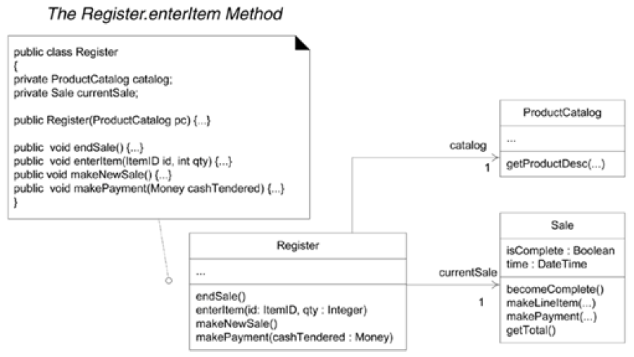
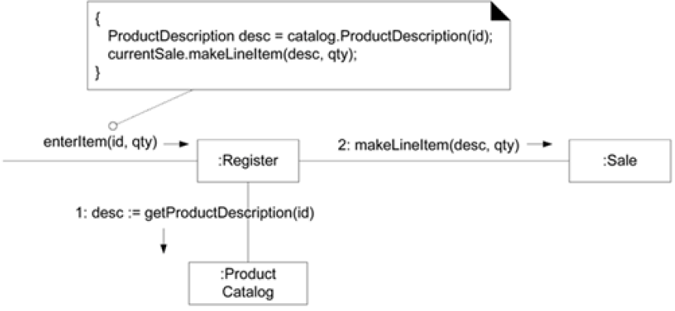
Defining the Sale—makeLineItem Method (sale.makeLineltem)
As a final example, the makeLineltem method of class Sale can also be written by inspecting the enterltem communication diagram.
Here, in response to the method invocation (makeLineItem(----)), the sale object creates a saleLineObject and adds that item, which is done in a single method invocation makeItems.add (new SalesLineItem(spec,qty))
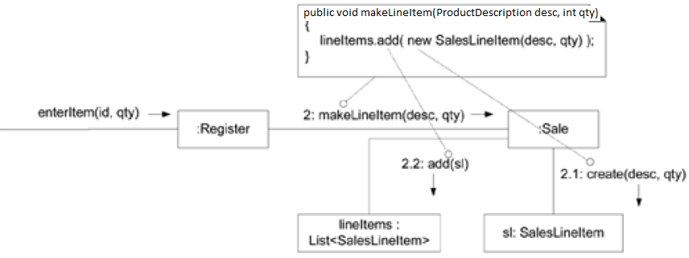
Collection Classes in Code
It is used to depict relationships line the one to many relationships
A Sale must maintain visibility to a group of may SalesLineItem instances
These relationships are usually maintained in OO programming languages with the collection of objects such as arrays, List or Map
Java libraries contain collection classes like ArrayList, HashMap that maintain list and map interfaces so using ArrayList the Sale can define an attribute that can maintain the ordered list of SalesLineItem instances
If an object implements an interface, declare the variable in terms of interface , not in terms of concrete class
private List lineItems = new ArrayList();
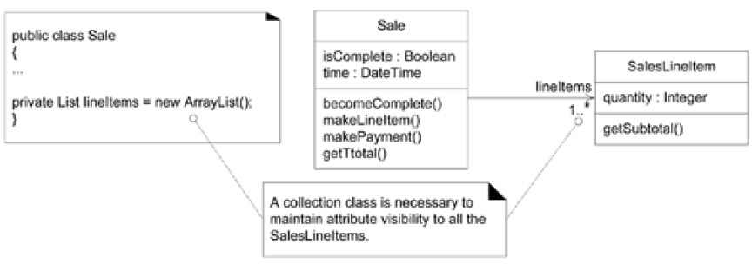

Ordering of Classes
Classes need to be implemented (and ideally, fully unit tested) from least-coupled to most-coupled
For example, possible first classes to implement are either Payment or ProductDescription; next are classes only dependent on the prior implementations— ProductCatalog or SalesLineltem.

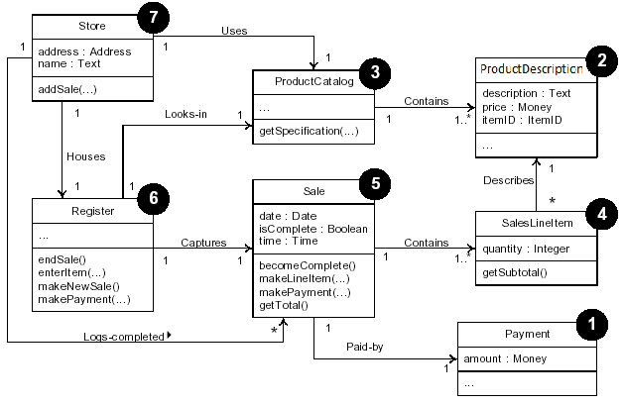
Exceptions in the UML
In the UML, an Exception is a specialization of a Signal, which is the specification of an
asynchronous communication between objects. This means that in interaction diagrams,
Exceptions are illustrated as asynchronous messages.

The UML has default syntax for operations but it doesn’t include an official solution to show exceptions thrown by an operation
Three solutions:
1. The UML allows the operation syntax to be any other language, such as Java, in addition, some UML CASE tools allow display of operations explicitly in Java syntax :
object get(key, class) throws DBUnavailableException, FatalException
2. The default syntax allows the last element to be a “property string” this is a list of arbitrary property + value pairs such as
{ author = Craig, kids =(Hannah, Haley) } thus
put(Object id){throws = (DBUnavailableException, FatalException)}
3. Some UML CASE tools allow one to specify (in a special dialbox) the exceptions that an operation throws
